Development of the modern virtual reality technologies
About InTech Industry Ltd, Moscow, Russia
Our main field of activity is development of multiuser 3D virtual systems with high level of interactivity and a wide range of communication features and elements of artificial intelligence.
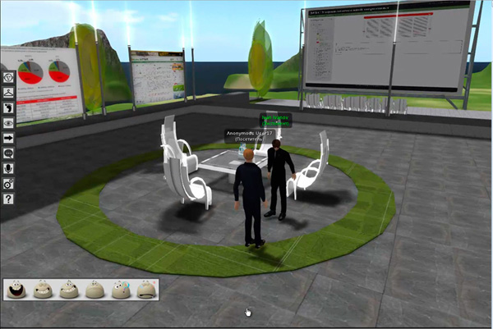
In virtual environments, created by our company, users who are represented as «avatars», could move and communicate in various ways between themselves, could learn in virtual classes, simulate almost any real situation, make presentations, sell or buy various goods, products or services, sharing the necessary information – everything like in the real life.
Video example 1
Technologies
Today the Company is one of technology leaders, not only in Russia but also in Europe, and is presenting new innovative software system, the main features of which are:
- Full freedom of actions, movements and communications of multiple users in a virtual world (more than 1,000 people at once.) Each user in the virtual world can be superficially similar to its owner in reality. We have provided a powerful appearance editor- you can change even the smallest detail of the face and body of the avatar. Available audio and video communication, chat, convenient panel realized emotions and gestures. Never before has the process of communicating online been so much fun!
- The highest level of interactive virtual environment - you can create (recreate) any interior with active objects that could be changed at any time; objects could be moved, modify, destroy, etc. For example, your avatar can operate a computer in virtual reality and open on it Internet sites, or view the video from the Internet.
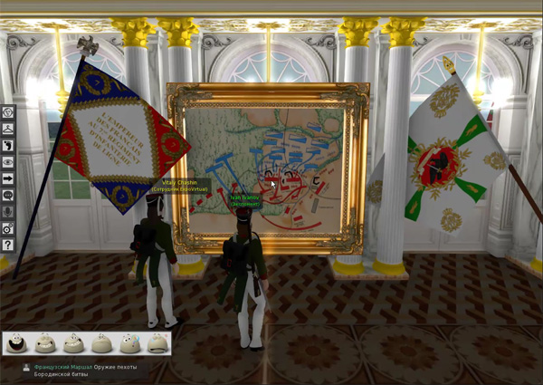

Video example 2

- The quality of 3D graphics is the same or better than in the most modern computer games.
We use deferred rendering, which allows simultaneously calculate practically unlimited number of light sources in the scene. Also many technologies, used by modern three-dimensional engine, are involved-antialiasing, depth of field, anisotropic texture filtering, and more. Support for hardware tessellation is under development.
- Virtual space are created with using of our own SDK, which our company develops from 2009, and it gives great abilities to automate and speed up the process of building multi-dimensional virtual reality systems.The key idea of SDK is an architecture of “virtual application”, according to which the programmer is no longer needs to share an application to a client and server sides, it is actually developing as local. But with installation of such application in virtual environment this application becomes multi-user and shares between users static and dynamic information (by “static” we mean an actions of application in virtual environment, for example, adding a new object, and by “dynamic” – the state of application itself, for example, state of a web page on screen in a virtual world). Such realization makes possible, for example, co-browsing in a virtual environment.
- On the basis of our software system, it is possible to create many services and projects different by purposes and application areas; for example, created in July 2012, unique in its functionality Virtual Exhibition Centre on 70 pavilions available for a guest visit. The detailed information about this center is available on http://www.expovirtual.ru
- Easy installation and log into the virtual space, and good usability of it is one of the advantages of the system, improvement of which is an everyday work of our team. The client application is installed on the user's computer, as well as any modern application with an intuitive wizard-installer, but it further integrates with the Windows shell, creating a new type of hyperlink, "a reference to the virtual space." And then, the user only has to click on the shortcut on the desktop or click on the link on the site using any browser, and he/she will appear directly at the desired location of the virtual space according to the coordinates specified by the link. While in the virtual world, the user can also "teleport" by a single click from one point to another. For example, instantly move from one virtual class, at the end of training sessions to another. The system automatically tunes to the correct graphics settings, depending on the performance of your computer and graphics card (the minimum requirements are not high). Intuitive avatar and camera controls, as well as usable functions and emotions panels allow even unfamiliar with computer person to feel comfortable and confident in virtual reality.

Applications of virtual reality systems
- Distance learning systems (“virtual academy”)
Created by our company virtual space offers the perfect place for a "immersion training", that is, learning with immersion in an environment with access to students regardless of their location
Learning system is typically a multi-user interactive three-dimensional virtual space, which deployed a cluster of classes for each course. Each class, depending on the content of a course, has its own appearance and means of presenting materials, such as screens, interactive whiteboards etc.
Virtual Academy is easy to integrate and interact with any of the known distance learning systems (LMS). Two-way exchange of information between the virtual environment and LMS is based on SCORM protocol and extended statistics students' actions in virtual space is gathered together with grades and answers to SCORM tests
According to the scenario and methodology of each course training sessions in a virtual reality could consists of self-paced training and synchronous training in the virtual classroom a virtual classroom. So, it is possible to realize the most effective blended learning.
In more complex cases, our virtual spaces can simulate an interactive environment that reproduces fragments of the real world and could be used in training.
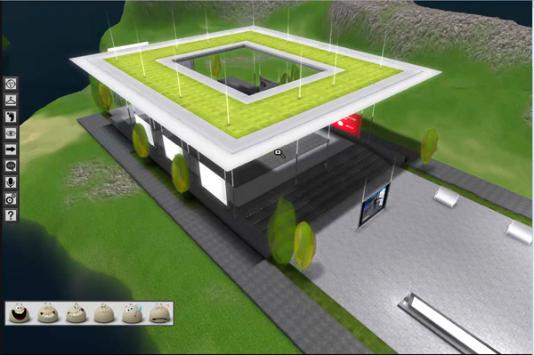
Such environment can range from a geographic and historical installation to layout of institutions, streets, houses, shops, etc.
The virtual environment allows easy and relatively cheap to use new approaches to distance learning - such as blended learning, constructivism and connectionism.
Proper design of the course allows the potential of the so-called hidden knowledge, ie knowledge that arises on the basis of personal experience and is transmitted only from person to person
Learning opportunities in our virtual reality is truly vast and can be limited only by imagination of the customer.

- Simulations.
Ordinary three-dimensional modeling of complex interiors, facilities, equipment or machinery in our century has become commonplace. In simulations, our company has stepped far beyond simple 3D modeling software to the generation of multiuser online virtual three-dimensional environment with 3D-objects that can change and respond to the impact of users located within the environment, or over time.
Instructor (teacher) together with the trainees (students) comes from their home or office computers to the previously created 3D-virtual environment (room, classroom, office, factory, etc.) with a variable object of study within.
All participants through their avatars can freely communicate and navigate through a virtual environment, affecting the objects of study. For example, include the switches, buttons, etc. Our system is able to simulate a three-dimensional mechanism, process or object in any complex configuration and to "revive" even the finest detail, or part of it.
Depending on the simulated situation teacher or instructor can teach (or check availability) of students (employees) to respond appropriately to emergency situations, such as, for example, emergency stop conveyor or a fire, taught how to use the complicated equipment, depending on the situation. Possible to simulate virtually any situation with the number of students more than 1,000 people at a time.
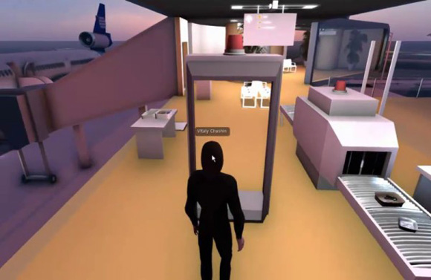
Video example 3

It is possible to fully automate the process in the modeling of a situation and to provide training and supervision of knowledge without a teacher, which is especially useful in integration with the LMS. A mixed approach is possible to.
Simulations in virtual reality - it is a high performance of staff training and employees at minimum cost.
Other applications based on our technology are virtual exhibitions, offices and shops.

The technology and software systems developed by our company are highly estimated and successfully used in such companies as Aeroflot-Russian Airlines, MTS (Mobile Telephone System), the Ministry of Culture of Russian Federation.

Contacts:
http://www.3D-Virtual.ru
contact@3D-Virtual.ru

